**React**

**Day 13th**

**Template language JSX**

JSX means JavaScript XML or JavaScript extension it allows to combine HTML and JavaScript in react. It looks similar to HTML but this is not HTML. This is JavaScript and combined with JavaScript and HTML in react. this syntax allows us to write HTML code in React. Without JSX it is very difficult to create react application because it’s very difficult to handle native element and difficult to maintain and debug. So they introduced JSX. It is javascript only but not browser standard JS it is next version of JS if you want to render it to browser definitely we need babel JS which converts JSX internally to browser standard version.

**Dive in the code**

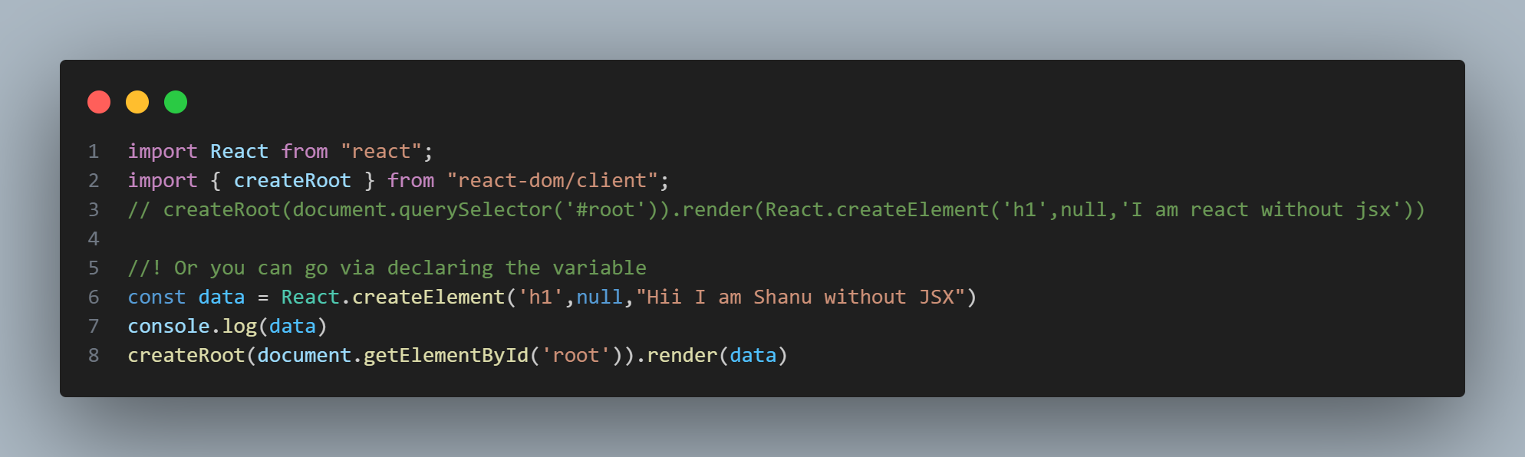Let’s learn first without using JSX.

It will return an object which have some methods and properties

**$$typeof**

After adding the $$typeof we could check an element is valid using $$typeof property: //The Symbol used to tag the ReactElement type. If there is no native Symbol. //nor polyfill, then a plain number is used for performance.

**Why do react elements have a $$typeof property??**

If you used React you might be familiar with type, props, key and ref fields but what is $$typeof?? And why does it have a Symbol() as a value??

That’s another one of those things that you don’t need to know to use react, but that will make you feel good when you do. There’s also some tips about security in this post.

In an application you can get many library. So we can get conflictions over there to avoid that react uniquely decided to use $$typeof means this is identifying this is react element. It is just for security reason.